**POWER SYSTEM PROTECTION TERM PROJECT REPORT:**

**Introduction:**

In this semester the term Project for our Course EE466-Power System Protection was about planning a defensive plan for a full power system. We are approached to plan a power system containing various parts like Power Grid (As a main source), Transformers, Induction Motors, Synchronous Motor, Circuit Breakers and Loads. The recently referenced parts were planned and associated by the accompanying boundaries:

|  |  |  |
| --- | --- | --- |
| **Sr. No.** | **Component** | **Input Parameters** |
| 1 | Power Grid U1 (Main Source) | 3-Phase: MVAsc = 2000, X/R = 55 |
| 2 | Transformer 1 | 3-Phase: 10 MVA, 115/13.8 kV, 7.5 %Z, Delta-Wye |
| 3 | Transformer 2 | 3-Phase: 20 MVA, 115/13.8 kV, 7.5 %Z, Delta-Wye |
| 4 | Transformer 3 | 3-Phase: 15 MVA, 115/13.8 kV, 6.5 %Z, Delta-Wye |
| 5 | Gen1 (Generator) | Subtransient Model, Round Rotor, Typical Data. |
| 6 | LUMP1 (Lump Load) | 70% Motor Load & 30% Static Load, LRC = 650%, “High”; X/R=15; Use “Std MF” Option |
| 7 | Transformer 4 | 3-Phase: 5 MVA, 13.8/4.16 k, 6.5 %Z, Delta-Wye, -1.25%TapP |
| 8 | Transformer 5 | 3-Phase: 5 MVA, 13.8 kV/4.16, 7 %Z, Delta-Wye, -1.25%TapP |
| 9 | Syn1 (Synchronous Motor) | 3-Phase: 2000 HP, Quantity = 2, 4 kV, 650%LRC |
| 10 | Cable1 (Cable) | Copper Cable, Length = 1500 ft, Z = 0.0223 + j0.0497 ohms/1000ft, Tmin = 50, Tmax = 75 |
| 11 | Transformer 6 | 3-Phase: 2 MVA, 4.16/0.48 kV, 7 %Z, Delta-Delta, -2.50001%TapP |
| 12 | Mtr5 (Induction Motor) | Use “Std MF” Option |
| 13 | Mtr1 (Induction Motor) | Quantity = 4, Use “Std MF” Option |
| 14 | Load1 (Static Load) | 2 MVA, 4.16 kV |
| 15 | Mtr2 (Induction Motor) | Quantity = 4, Use “Std MF” Option |
| 16 | Mtr3 (Induction Motor) | Quantity = 5, Use “Std MF” Option |
| 17 | Mtr4 (Induction Motor) | Use “Std MF” Option |
| 18 | Load2 (Static Load) | 1 MVA, 0.48 kV |

**Protective Components:**

|  |  |
| --- | --- |
| **Breaker Number** | **Type** |
| CB1, CB3, CB4, CB5, CB6, CB7, CB8, CB9, CB10, CB11, CB12, CB13, CB14, CB15, CB16, CB17, CB18, CB19 | High Voltage Circuit Breaker |
| CB20, CB21, CB22, CB23 | Low Voltage Circuit Breaker |

The report shows the plan of the protection plan on ETAP and how the Components are connected. It additionally shows the Protection type for each component and the type of relay along with the CT Ratio after the Proper Calculations.

The Report also contains screenshots of results which were obtained from ETAP i.e., “Load Flow Analysis” , “Short Circuit Analysis” , and the “Sequence of Relay Operation For Tripping a Specific Circuit Breaker”.

We are asked to show all the results for TWO Configurations.

In First Configuration CB-1 is closed-tie.

Whereas, in Second Configuration CB-1 is open.

**Procedure:**

We are asked to design Protection Scheme of Given Power System for TWO Configurations:

* **Closed Tie CB-1 (Normal Configuration)**
* **CB-1 (Open)**

Let’s start with 1st Configuration.

1. **Closed tie CB-1 (Normal Configuration):**

We began the Circuit in ETAP by adding every of the parts which is mentioned above to the ETAP “Edit Mode” and connected them to obtain the Required Diagram. We entered the details of each component as needed by the recently referenced Table. Thus, We obtain Full Circuit Diagram as Shown in Figure 1.

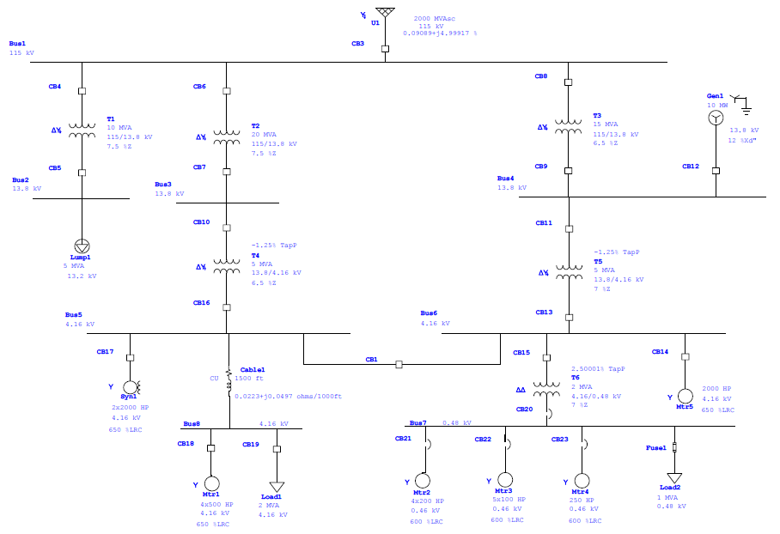

***Fig. 1 Power System Diagram (Close-tie Configuration)***

For Protecting our components we have to set Relays. For setting Relays we need to configure Current Transformer (CT). For CT we need CT Ratio as an Input Value for CT. For Turn Ratio of CT we need Maximum Load Current Flowing through each component. So, To get this data Firstly we did a Load Flow Analysis of this Power System. It brought about showing the current and the power of each branch in the diagram. These outcomes are appeared in Figure 2.

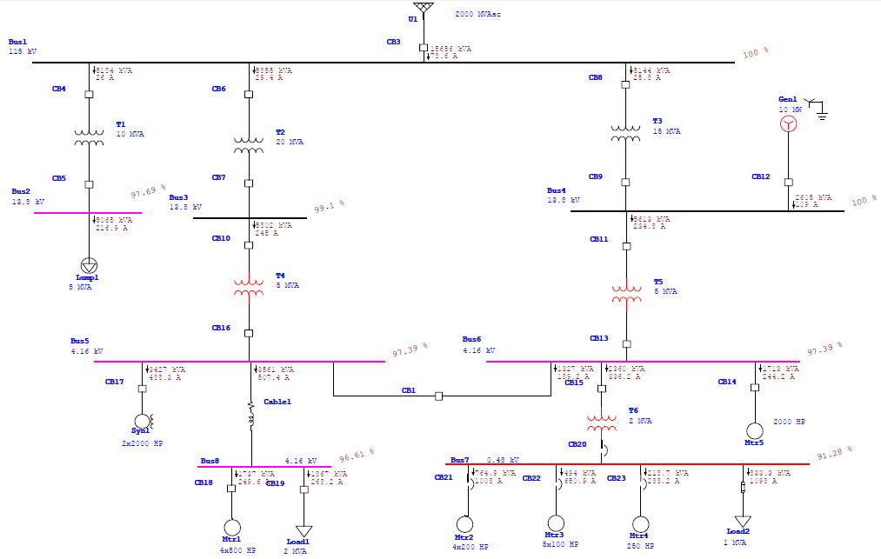

***Fig. 2 Power System Diagram After Running Load Flow Analysis (Close-tie Configuration)***

***Conclusion Obtained From Load Flow Analysis,***

|  |  |  |
| --- | --- | --- |
| ***Component*** | ***Maximum Load Current (A)*** | ***Apparent Power (kVA)*** |
| ***U1 Power Grid*** | *78.6* | *15656* |
| ***Transformer 1*** | *26* | *5184* |
| ***Transformer 2*** | *29.4* | *5855* |
| ***Transformer 3*** | *25.8* | *5144* |
| ***Transformer 4*** | *245* | *5802* |
| ***Transformer 5*** | *234.8* | *5613* |
| ***Transformer 6*** | *336.2* | *2360* |
| ***Lump1*** | *216.9* | *5065* |
| ***Gen1*** | *109* | *2605* |
| ***Syn1*** | *488.3* | *3427* |
| ***Cable1*** | *507.4* | *2561* |
| ***Motor1*** | *249.6* | *1737* |
| ***Motor2*** | *1008* | *764.9* |
| ***Motor3*** | *650.9* | *494* |
| ***Motor4*** | *288.2* | *218.7* |
| ***Motor5*** | *244.2* | *1713* |
| ***Load1*** | *268.2* | *1867* |
| ***Load2*** | *1098* | *833.3* |

***Table 1 Load Flow Results (Close-tie Configuration)***

For Turn Ratio of CT we also need the Fault Current Flowing through each component. So, to get fault currents we did a Short Circuit Analysis of this Power System. It brought about showing the Fault Current of each branch in the diagram. These outcomes are appeared in Figure 3.

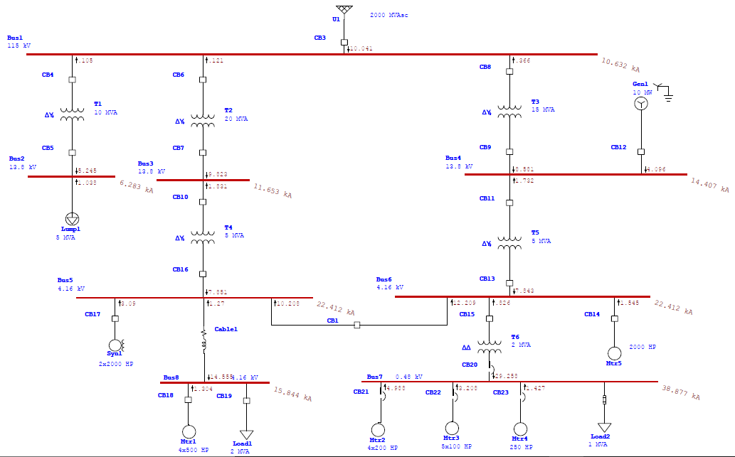

***Fig. 3 Power System Diagram After Running Short Circuit Analysis (Close-tie Configuration)***

Now we need to choose the CT ratios and relays properly to trip the circuit Breaker Properly. Below Table shows the Standard CT Ratios.

Then we have to choose nearest CT Ratio from the Below Table.

|  |  |  |
| --- | --- | --- |
| **Sr. No.** | **Manufacturer’s Maximum Production** | **Standard Values** |
| **1** | 600:5 | 50:5, 100:5, 150:5, 200:5, 250:5, 300:5, 400:5, 450:5, 500:5, 600:5 |
| **2** | 1200:5 | 100:5, 200:5, 300:5, 400:5, 500:5, 600:5, 800:5, 900:5, 1000:5, 1200:5 |
| **3** | 2000:5 | 300:5, 400:5, 500:5, 800:5, 1100:5, 1200:5, 1500:5, 1600:5, 2000:5 |
| **4** | 3000:5 | 300:5, 500:5, 800:5, 1000:5, 1200:5, 1500:5, 2000:5, 2200:5, 2500:5, 3000:5 |
| **5** | 4000:5 | 500:5, 1000:5, 1500:5, 2000:5, 2500:5, 3000:5, 3500:5, 4000:5 |
| **6** | 5000:5 | 500:5, 1000:5, 1500:5, 2000:5, 2500:5, 3000:5, 3500:5, 4000:5, 5000:5 |

***Table 2 Standard CT Values***

With the reference from Table of Standard CT Values and Maximum Load Current **IMAX-LOAD** (which we get after Load Flow Analysis). To increase the relay’s Protection Capability, we will always choose values that are closer to the **IMAX-LOAD**.

|  |  |  |  |
| --- | --- | --- | --- |
| **Sr. No.** | **Component** | **IMAX-LOAD (A)** | **CT Ratio** |
| **1** | Power Grid | 78.6 | 100:5 |
| **2** | Transformer 1 (Primary Side) | 26 | 50:5 |
| **3** | Transformer 1 (Secondary Side) | 216.9 | 250:5 |
| **4** | Transformer 2 (Primary Side) | 29.4 | 50:5 |
| **5** | Transformer 2 (Secondary Side) | 245 | 250:5 |
| **6** | Transformer 3 (Primary Side) | 25.8 | 50:5 |
| **7** | Transformer 3 (Secondary Side) | 234.8 | 250:5 |
| **8** | Transformer 4 (Primary Side) | 245 | 250:5 |
| **9** | Transformer 4 (Secondary Side) | 1184.9 | 1200:5 |
| **10** | Transformer 5 (Primary Side) | 234.8 | 250:5 |
| **11** | Transformer 5 (Secondary Side) | 769.6 | 800:5 |
| **12** | Transformer 6 (Primary Side) | 336.2 | 400:5 |
| **13** | Transformer 6 (Secondary Side) | 3045.1 | 3500:5 |
| **14** | Gen1(Generator) | 109 | 150:5 |
| **15** | Syn1 (Synchronous Motor) | 488.3 | 500:5 |
| **16** | Mtr1 (Induction Motor) | 249.6 | 300:5 |
| **17** | Mtr2 (Induction Motor) | 1008 | 1100:5 |
| **18** | Mtr3 (Induction Motor) | 650.9 | 800:5 |
| **19** | Mtr4 (Induction Motor) | 288.2 | 300:5 |
| **20** | Mtr5 (Induction Motor) | 244.2 | 250:5 |
| **21** | Load1 (Static Load) | 268.2 | 300:5 |

***Table 3 Selected CT Values***

After Adding the Current Transformers (CT’s), Over-Current Relays & Differential Relays (For Differential Protection of Transformers) the Power System Diagram Looks:

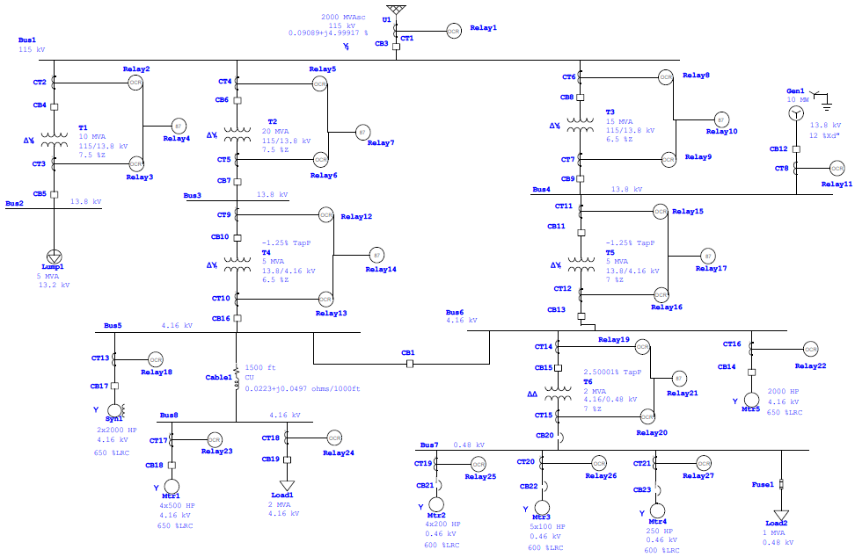

***Fig. 4 Power System Diagram After adding CT’s & Relays (Close-tie Configuration)***

Now it’s time to select Relay Model from ETAP Library & to Calculate IPickup For Each Component, From IPickup we get Pickup Value.

To calculate Ipickup we use the following relation,

**2 x IMax-Load < IPickup < 1/3 x IMax-Fault**

**For Power Grid U1 (Main Source):**

As IPickup,

2 x IMax-Load < IPickup

2 x 78.6 < IPickup

157.2 < IPickup

**For T1 (High Voltage Side):**

2 x 26 < IPickup

52 < IPickup

**For T1 (Low Voltage Side):**

2 x 216.9 < IPickup

433.8 < IPickup

**For T2 (High Voltage Side):**

2 x 29.4 < IPickup

58.8 < IPickup

**For T2 (Low Voltage Side):**

2 x 245 < IPickup

490 < IPickup

**For T3 (High Voltage Side):**

2 x 25.8 < IPickup

51.6 < IPickup

**For T3 (Low Voltage Side):**

2 x 234.8 < IPickup

469.6 < IPickup

**For T4 (High Voltage Side):**

2 x 245 < IPickup

490 < IPickup

**For T4 (Low Voltage Side):**

2 x 1184.9 < IPickup

2369.8 < IPickup

**For T5 (High Voltage Side):**

2 x 234.8 < IPickup

469.6 < IPickup

**For T5 (Low Voltage Side):**

2 x 769.6 < IPickup

1539.2 < IPickup

**For T6 (High Voltage Side):**

2 x 336.2 < IPickup

672.4 < IPickup

**For T6 (Low Voltage Side):**

2 x 3045.1 < IPickup

6090.2 < IPickup

**For Gen1:**

2 x 109 < IPickup

218 < IPickup

**For Syn1:**

2 x 488.3 < IPickup

976.6 < IPickup

**For Mtr1:**

2 x 249.6 < IPickup

499.2 < IPickup

**For Mtr2:**

2 x 1008 < IPickup

2016 < IPickup

**For Mtr3:**

2 x 650.9 < IPickup

1301.8 < IPickup

**For Mtr4:**

2 x 288.2 < IPickup

576.4 < IPickup

**For Mtr5:**

2 x 244.2 < IPickup

488.4 < IPickup

**For Load1:**

2 x 268.2 < IPickup

536.4 < IPickup

In ETAP, if we enter Pickup value in relay settings then it automatically IPickup. So, we randomly entered some values for Pickup to get Desired IPickup for every component. By this Process we got Pickup value for Every Component. So, we make following Table. The specifications of relays also showed in Table 4.

|  |  |  |  |  |  |  |  |
| --- | --- | --- | --- | --- | --- | --- | --- |
| **Sr. No.** | **Component** | **Relay ID** | **Relay Model** | **Protection Type** | **IPickup** | **Pickup value** | **Relay Output** |
| **1** | Power Grid | Relay1 | ABB 50D | Time delay over current | 157.2< | 8 | Open CB3 |
| **2** | Transformer 1 (Primary Side) | Relay2 | ABB 50D | Time delay over current | 52< | 5.3 | Open CB4 |
| **3** | Transformer 1 (Secondary Side) | Relay3 | ABB 50D | Time delay over current | 433.8< | 8.7 | Open CB5 |
| **4** | Transformer 1 | Relay4 | ABB HU | Differential | - | - | Open CB4-CB5 |
| **5** | Transformer 2 (Primary Side) | Relay5 | ABB 50D | Time delay over current | 58.8< | 5.9 | Open CB6 |
| **6** | Transformer 2 (Secondary Side) | Relay6 | ABB 50D |  | 490< | 9.9 | Open CB7 |
| **7** | Transformer 2 | Relay7 | ABB HU | Differential | - | - | Open CB6-CB7 |
| **8** | Transformer 3 (Primary Side) | Relay8 | ABB 50D | Time delay over current | 51.6< | 5.2 | Open CB8 |
| **9** | Transformer 3 (Secondary Side) | Relay9 | ABB 50D | Time delay over current | 469.6< | 9.4 | Open CB9 |
| **10** | Transformer 3 | Relay10 | ABB HU | Differential | - | - | Open CB8-CB9 |
| **11** | Transformer 4 (Primary Side) | Relay12 | ABB 50D | Time delay over current | 490< | 9.9 | Open CB10 |
| **12** | Transformer 4 (Secondary Side) | Relay13 | ABB 50D | Time delay over current | 2369.8< | 9.9 | Open CB16 |
|  | Transformer 4 | Relay14 | ABB HU | Differential | - | - | Open CB10-CB16 |
| **13** | Transformer 5 (Primary Side) | Relay15 | ABB 50D | Time delay over current | 469.6< | 9.4 | Open CB11 |
| **14** | Transformer 5 (Secondary Side) | Relay16 | ABB 50D | Time delay over current | 1539.2< | 19.3 | Open CB13 |
| **15** | Transformer 5 | Relay17 | ABB HU | Differential | - | - | Open CB11-CB13 |
| **16** | Transformer 6 (Primary Side) | Relay19 | ABB 50D | Time delay over current | 672.4< | 8.5 | Open CB15 |
| **17** | Transformer 6 (Secondary Side) | Relay20 | ABB 50D | Time delay over current | 6090.2< | 8.71 | Open CB20 |
| **18** | Transformer 6 | Relay21 | ABB HU | Differential | - | - | Open CB15-CB20 |
| **19** | Syn1 (Synchronous Motor) | Relay18 | GE Multilin IAC-66M | Time delay over current | 976.6< | 9.8 | Open CB17 |
| **20** | Mtr1 (Induction Motor) | Relay23 | GE Multilin IAC-66M | Time delay over current | 499.2< | 10,9 | Open CB18 |
| **21** | Mtr2 (Induction Motor) | Relay25 | GE Multilin IAC-66M | Time delay over current | 2016< | 10 | Open CB21 |
| **22** | Mtr3 (Induction Motor) | Relay26 | GE Multilin IAC-66M | Time delay over current | 1301.8< | 10 | Open CB22 |
| **23** | Mtr4 (Induction Motor) | Relay27 | GE Multilin IAC-66M | Time delay over current | 576.4< | 10 | Open CB23 |
| **24** | Mtr5 (Induction Motor) | Relay22 | GE Multilin IAC-66M | Time delay over current | 488.4< | 10 | Open CB14 |
| **25** | Load1 (Static Load) | Relay24 | GE Multilin IAC-66M | Time delay over current | 536.4< | 9 | Open CB19 |
| **26** | Gen1 (Generator) | Relay 11 | GE Multilin 489 |  | 218< | 1.5 | Open CB12 |

***Table 4 Relay Specifications for each component***

Now, it’s time to check our protection scheme. Go, to star Protection & Coordination system. Run 3-Phase Symmetrical fault on every Bus one by one and check the tripping operation of Circuit breakers.

**FAULT AT BUS 1:**

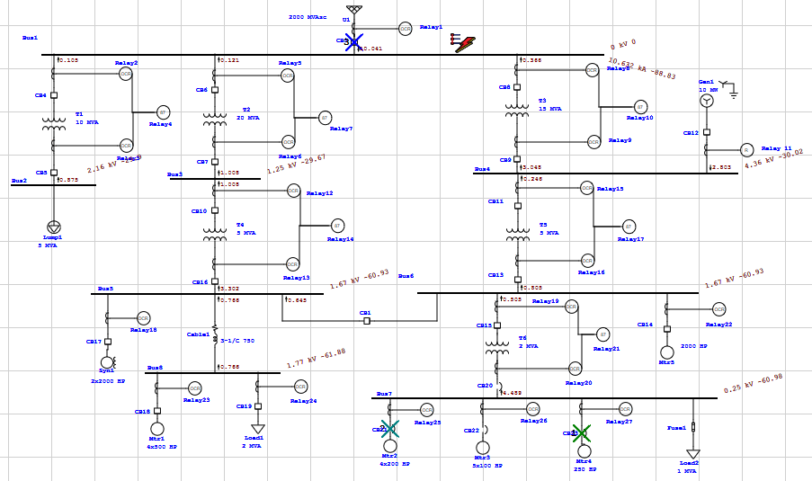

***Fig. 5 Fault at Bus 1(Closed tie configuration)***

**Relay Sequence Operation:**

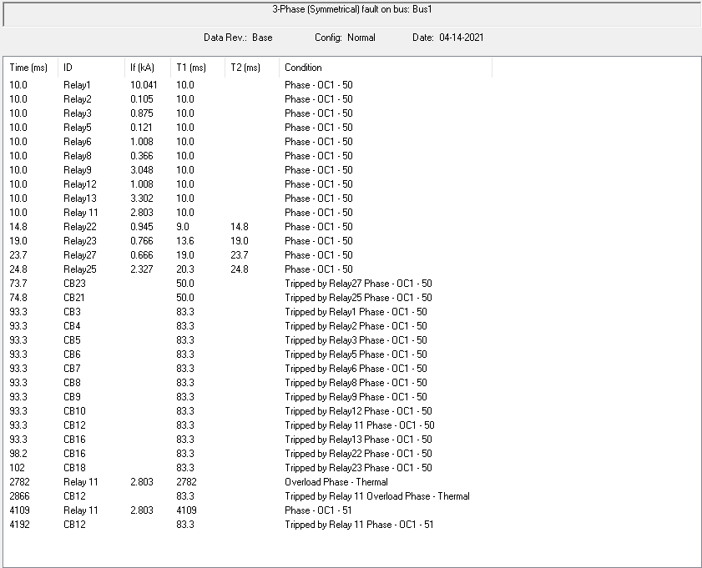

***Fig. 6 Relay Sequence of Operation***

**FAULT AT BUS 2:**

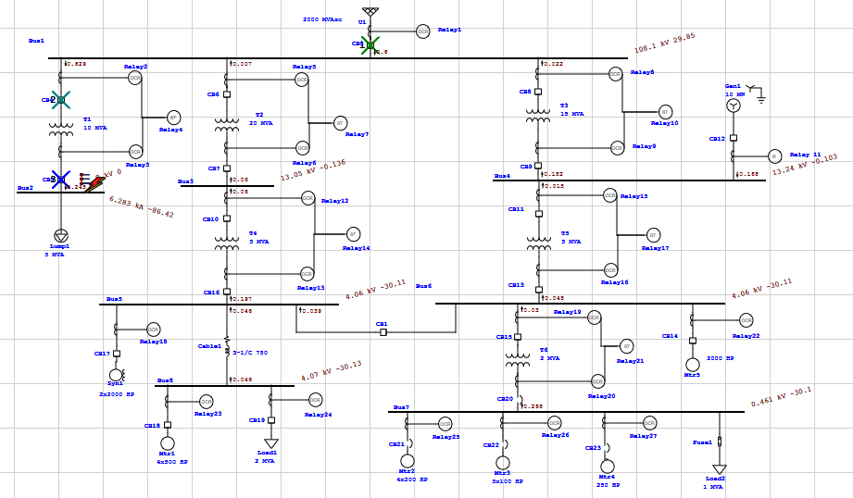

***Fig. 7 Fault at Bus 2(Closed tie configuration)***

**Relay Sequence Operation:**

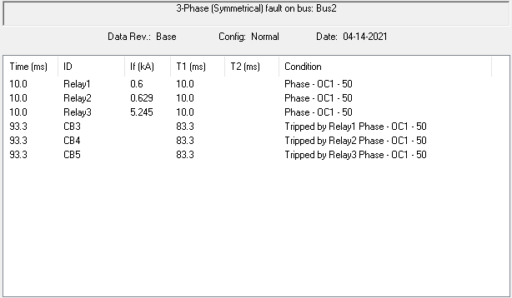

***Fig. 8 Relay Sequence of Operation***

**FAULT AT BUS 3:**

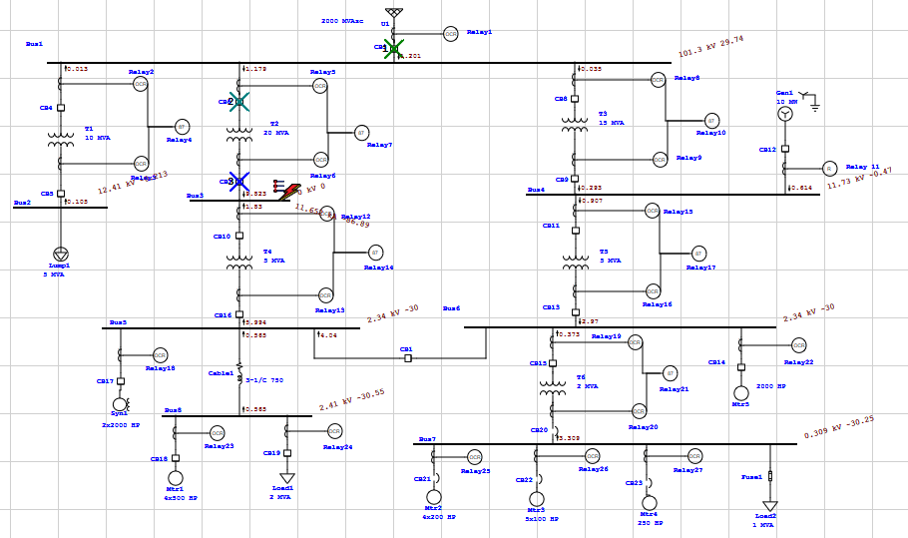

***Fig. 9 Fault at Bus 3(Closed tie configuration)***

**Relay Sequence Operation:**

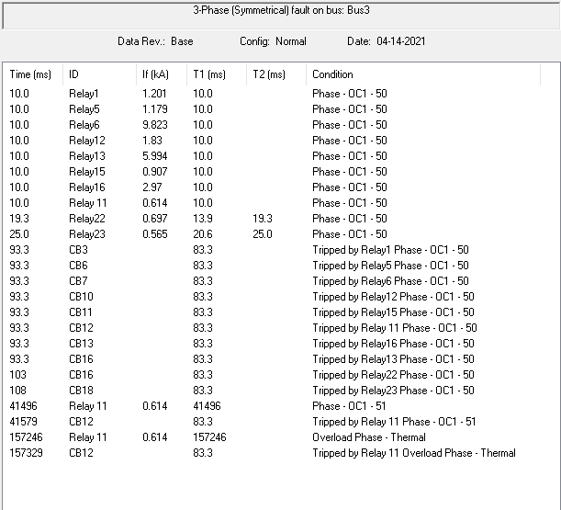

***Fig. 10 Relay Sequence of Operation***

**FAULT AT BUS 4:**

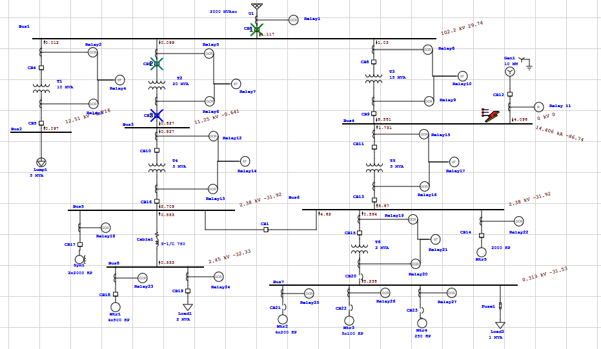

***Fig. 11 Fault at Bus 4(Closed tie configuration)***

**Relay Sequence Operation:**

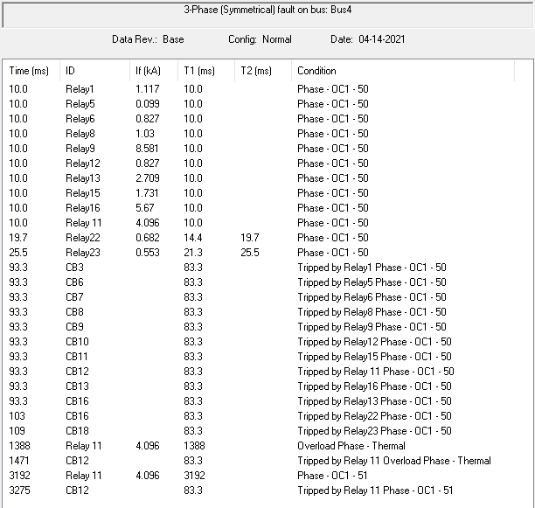

***Fig. 12 Relay Sequence of Operation***

**FAULT AT BUS 5:**

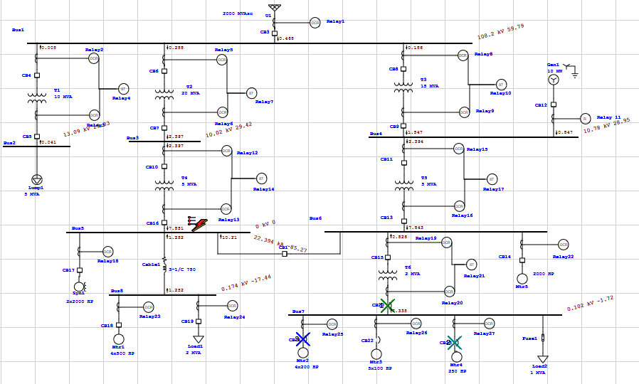

***Fig. 13 Fault at Bus 5(Closed tie configuration)***

**Relay Sequence Operation:**

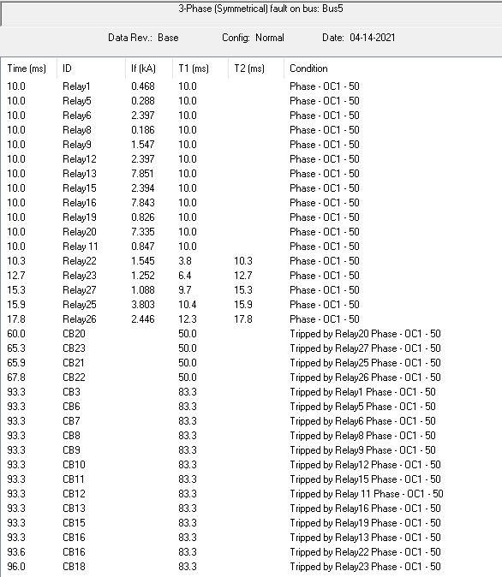

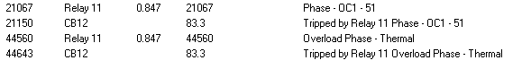

***Fig. 14 Relay Sequence of Operation***

**FAULT AT BUS 6:**

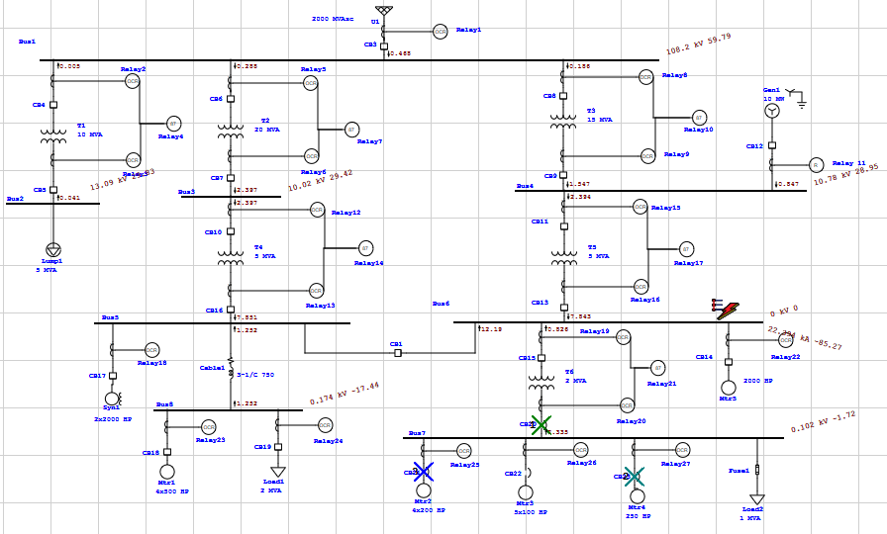

***Fig. 15 Fault at Bus 6(Closed tie configuration)***

**Relay Sequence Operation:**

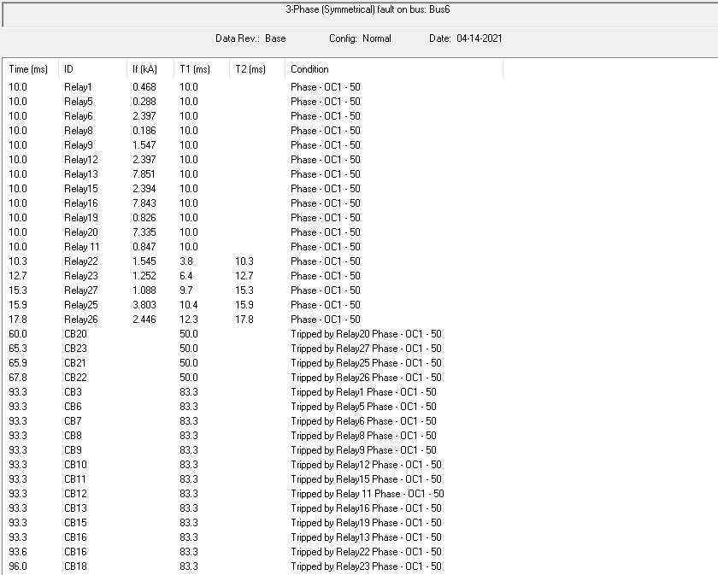





***Fig. 16 Relay Sequence of Operation***

**FAULT AT BUS 7:**

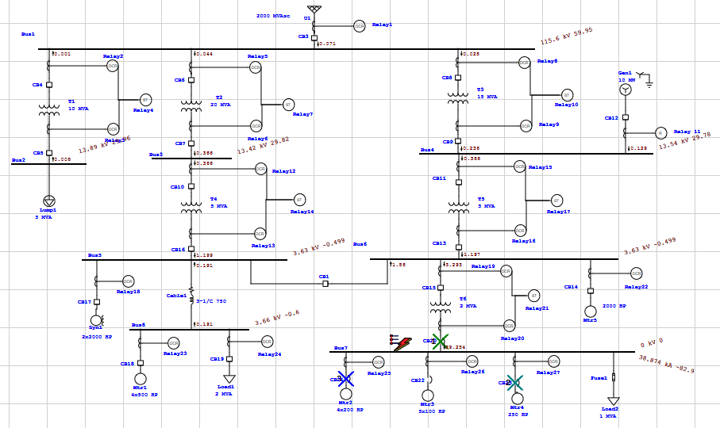

***Fig. 17 Fault at Bus 7(Closed tie configuration)***

**Relay Sequence Operation:**

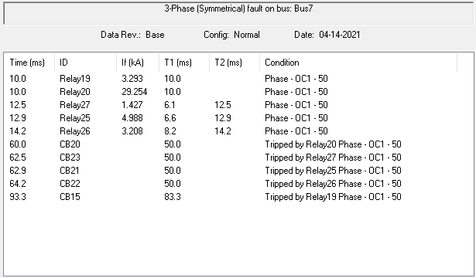

***Fig. 18 Relay Sequence of Operation***

**FAULT AT BUS 8:**

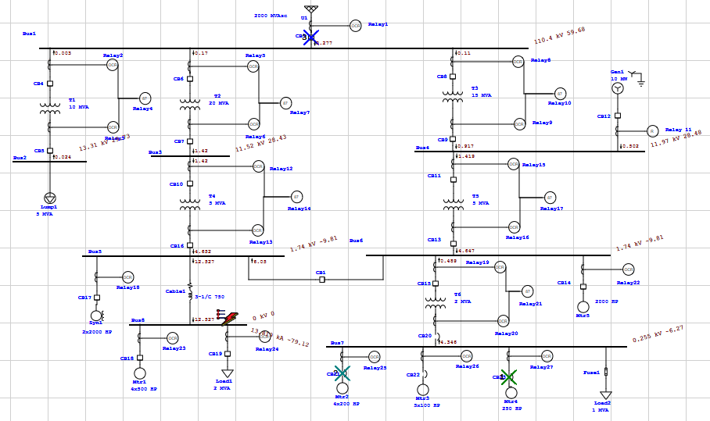

***Fig. 19 Fault at Bus 8(Closed tie configuration)***

**Relay Sequence Operation:**

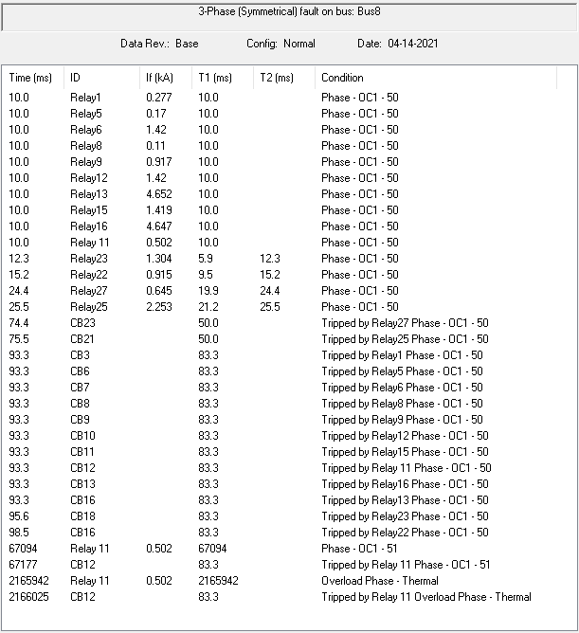

***Fig. 20 Relay Sequence of Operation***

1. **CB-1 (Open):**

Now in this step we change the state of Circuit Breaker (CB-1) from close to open. As shown in Figure Below.

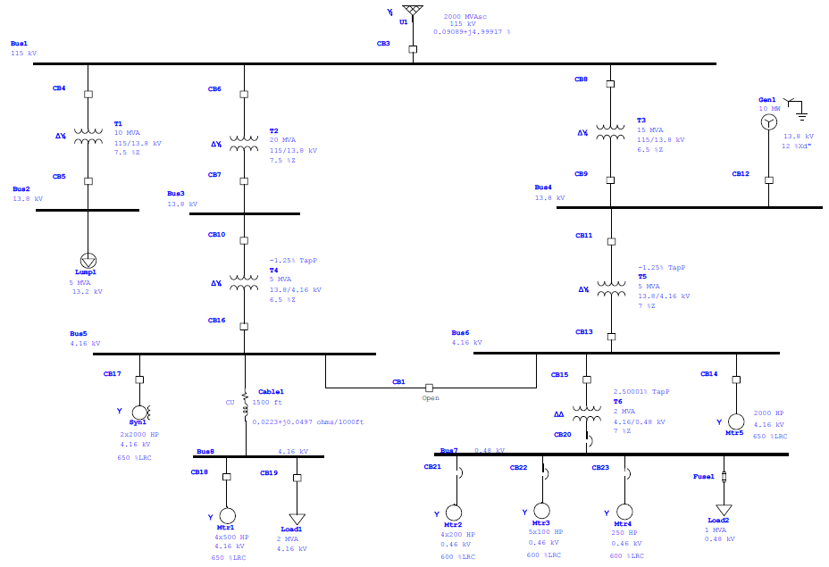

***Fig. 21 Power System Diagram (CB-1 Open Configuration)***

Again we repeat load flow analysis for CB-1 Open Configuration to obtain Maximum Load Current by which we can easily find CT Ratios for every component.

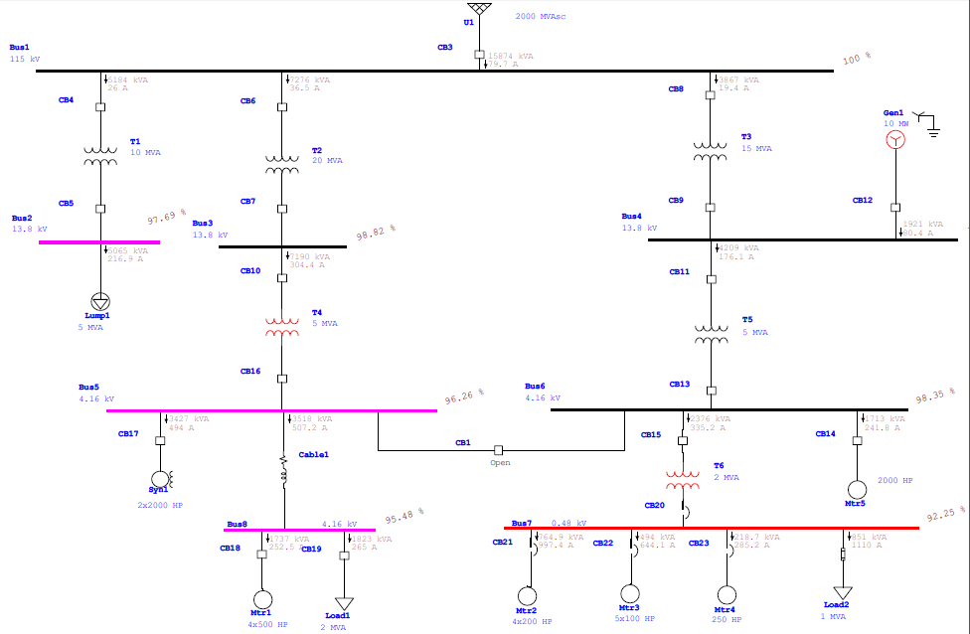

***Fig. 22 Power System Diagram After Running Load Flow Analysis (CB-1 Open Configuration)***

***Conclusion Obtained From Load Flow Analysis,***

|  |  |  |
| --- | --- | --- |
| ***Component*** | ***Maximum Load Current (A)*** | ***Apparent Power (kVA)*** |
| ***U1 Power Grid*** | *79.7* | *15874* |
| ***Transformer 1*** | *26* | *5184* |
| ***Transformer 2*** | *36.5* | *7276* |
| ***Transformer 3*** | *19.4* | *3867* |
| ***Transformer 4*** | *304.4* | *7190* |
| ***Transformer 5*** | *176.1* | *4209* |
| ***Transformer 6*** | *335.2* | *2376* |
| ***Lump1*** | *216.9* | *5065* |
| ***Gen1*** | *80.4* | *1921* |
| ***Syn1*** | *494* | *3427* |
| ***Cable1*** | *507.2* | *3518* |
| ***Motor1*** | *252.5* | *1737* |
| ***Motor2*** | *997.4* | *764.9* |
| ***Motor3*** | *644.1* | *494* |
| ***Motor4*** | *285.2* | *218.7* |
| ***Motor5*** | *241.8* | *1713* |
| ***Load1*** | *265* | *1823* |
| ***Load2*** | *1110* | *851* |

***Table 4 Load Flow Results (CB-1 Open Configuration)***

For Turn Ratio of CT we also need the Fault Current Flowing through each component. So, to get fault currents we did a Short Circuit Analysis of this Power System. It brought about showing the Fault Current of each branch in the diagram. These outcomes are appeared in Figure 23.

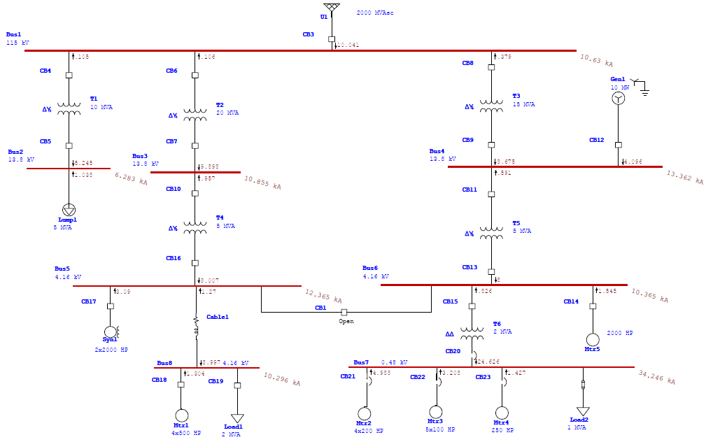

***Fig. 23 Power System Diagram After Running Short Circuit Analysis (CB-1 Open Configuration)***

Now we need to choose the CT ratios and relays properly to trip the circuit Breaker Properly. With the reference from Table of Standard CT Values and Maximum Load Current **IMAX-LOAD** (which we get after Load Flow Analysis). To increase the relay’s Protection Capability, we will always choose values that are closer to the **IMAX-LOAD**.

|  |  |  |  |
| --- | --- | --- | --- |
| **Sr. No.** | **Component** | **IMAX-LOAD (A)** | **CT Ratio** |
| **1** | Power Grid | 79.7 | 100:5 |
| **2** | Transformer 1 (Primary Side) | 26 | 50:5 |
| **3** | Transformer 1 (Secondary Side) | 216.9 | 250:5 |
| **4** | Transformer 2 (Primary Side) | 36.5 | 50:5 |
| **5** | Transformer 2 (Secondary Side) | 304.4 | 400:5 |
| **6** | Transformer 3 (Primary Side) | 19.4 | 50:5 |
| **7** | Transformer 3 (Secondary Side) | 176.1 | 200:5 |
| **8** | Transformer 4 (Primary Side) | 304.4 | 400:5 |
| **9** | Transformer 4 (Secondary Side) | 1001.2 | 1100:5 |
| **10** | Transformer 5 (Primary Side) | 176.1 | 200:5 |
| **11** | Transformer 5 (Secondary Side) | 577 | 600:5 |
| **12** | Transformer 6 (Primary Side) | 335.2 | 400:5 |
| **13** | Transformer 6 (Secondary Side) | 3036.7 | 3500:5 |
| **14** | Gen1(Generator) | 80.4 | 100:5 |
| **15** | Syn1 (Synchronous Motor) | 494 | 500:5 |
| **16** | Mtr1 (Induction Motor) | 252.5 | 300:5 |
| **17** | Mtr2 (Induction Motor) | 997.4 | 1000:5 |
| **18** | Mtr3 (Induction Motor) | 644.1 | 800:5 |
| **19** | Mtr4 (Induction Motor) | 285.2 | 300:5 |
| **20** | Mtr5 (Induction Motor) | 241.8 | 250:5 |
| **21** | Load1 (Static Load) | 265 | 300:5 |

***Table 6 Selected CT Values***

After Adding the Current Transformers (CT’s), Over-Current Relays & Differential Relays (For Differential Protection of Transformers) the Power System Diagram Looks:

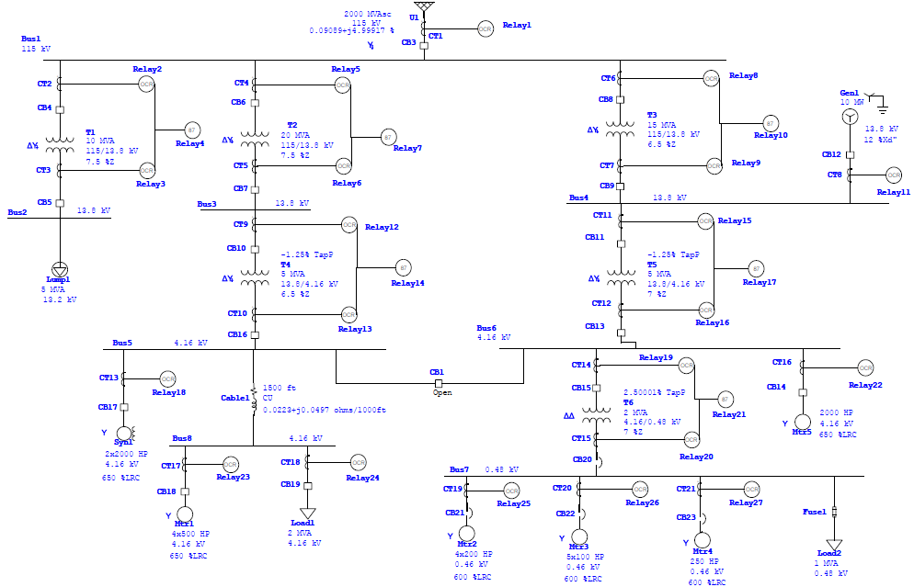

***Fig. 24 Power System Diagram After adding CT’s & Relays (CB-1 Open Configuration)***

Now it’s time to select Relay Model from ETAP Library & to Calculate IPickup For Each Component, From IPickup we get Pickup Value.

To calculate Ipickup we use the following relation,

**2 x IMax-Load < IPickup < 1/3 x IMax-Fault**

**For Power Grid U1 (Main Source):**

As IPickup,

2 x IMax-Load < IPickup

2 x 79.7 < IPickup

159.4 < IPickup

**For T1 (High Voltage Side):**

2 x 26 < IPickup

52 < IPickup

**For T1 (Low Voltage Side):**

2 x 216.9 < IPickup

433.8 < IPickup

**For T2 (High Voltage Side):**

2 x 36.5 < IPickup

73 < IPickup

**For T2 (Low Voltage Side):**

2 x 304.4 < IPickup

608.8 < IPickup

**For T3 (High Voltage Side):**

2 x 19.4 < IPickup

38.8 < IPickup

**For T3 (Low Voltage Side):**

2 x 176.1 < IPickup

352.2 < IPickup

**For T4 (High Voltage Side):**

2 x 304.4 < IPickup

608.8 < IPickup

**For T4 (Low Voltage Side):**

2 x 1001.2 < IPickup

2002.4 < IPickup

**For T5 (High Voltage Side):**

2 x 176.1 < IPickup

352.2 < IPickup

**For T5 (Low Voltage Side):**

2 x 577 < IPickup

1154 < IPickup

**For T6 (High Voltage Side):**

2 x 335.2 < IPickup

670.4 < IPickup

**For T6 (Low Voltage Side):**

2 x 3036.7 < IPickup

6073.4 < IPickup

**For Gen1:**

2 x 80.4 < IPickup

160.8 < IPickup

**For Syn1:**

2 x 494 < IPickup

988 < IPickup

**For Mtr1:**

2 x 252.5 < IPickup

505 < IPickup

**For Mtr2:**

2 x 997.4 < IPickup

1994.8 < IPickup

**For Mtr3:**

2 x 644.1 < IPickup

1288.2 < IPickup

**For Mtr4:**

2 x 285.2 < IPickup

570.4 < IPickup

**For Mtr5:**

2 x 241.8 < IPickup

483.6 < IPickup

**For Load1:**

2 x 265 < IPickup

530 < IPickup

In ETAP, if we enter Pickup value in relay settings then it automatically IPickup. So, we randomly entered some values for Pickup to get Desired IPickup for every component. By this Process we got Pickup value for Every Component. So, we make following Table. The specifications of relays also showed in Table.

|  |  |  |  |  |  |  |  |
| --- | --- | --- | --- | --- | --- | --- | --- |
| **Sr. No.** | **Component** | **Relay ID** | **Relay Model** | **Protection Type** | **IPickup** | **Pickup value** | **Relay Output** |
| **1** | Power Grid | Relay1 | ABB 50D | Time delay over current | 159.4< | 8 | Open CB3 |
| **2** | Transformer 1 (Primary Side) | Relay2 | ABB 50D | Time delay over current | 52< | 5.3 | Open CB4 |
| **3** | Transformer 1 (Secondary Side) | Relay3 | ABB 50D | Time delay over current | 433.8< | 8.7 | Open CB5 |
| **4** | Transformer 1 | Relay4 | ABB HU | Differential | - | - | Open CB4-CB5 |
| **5** | Transformer 2 (Primary Side) | Relay5 | ABB 50D | Time delay over current | 73< | 5.9 | Open CB6 |
| **6** | Transformer 2 (Secondary Side) | Relay6 | ABB 50D |  | 608.8< | 7.625 | Open CB7 |
| **7** | Transformer 2 | Relay7 | ABB HU | Differential | - | - | Open CB6-CB7 |
| **8** | Transformer 3 (Primary Side) | Relay8 | ABB 50D | Time delay over current | 38.8< | 5.2 | Open CB8 |
| **9** | Transformer 3 (Secondary Side) | Relay9 | ABB 50D | Time delay over current | 352.2< | 8.811 | Open CB9 |
| **10** | Transformer 3 | Relay10 | ABB HU | Differential | - | - | Open CB8-CB9 |
| **11** | Transformer 4 (Primary Side) | Relay12 | ABB 50D | Time delay over current | 608.8< | 7.65 | Open CB10 |
| **12** | Transformer 4 (Secondary Side) | Relay13 | ABB 50D | Time delay over current | 2002.4< | 9.114 | Open CB16 |
|  | Transformer 4 | Relay14 | ABB HU | Differential | - | - | Open CB10-CB16 |
| **13** | Transformer 5 (Primary Side) | Relay15 | ABB 50D | Time delay over current | 352.2< | 8.9 | Open CB11 |
| **14** | Transformer 5 (Secondary Side) | Relay16 | ABB 50D | Time delay over current | 1154< | 9.664 | Open CB13 |
| **15** | Transformer 5 | Relay17 | ABB HU | Differential | - | - | Open CB11-CB13 |
| **16** | Transformer 6 (Primary Side) | Relay19 | ABB 50D | Time delay over current | 670.4< | 8.5 | Open CB15 |
| **17** | Transformer 6 (Secondary Side) | Relay20 | ABB 50D | Time delay over current | 6073.4< | 8.71 | Open CB20 |
| **18** | Transformer 6 | Relay21 | ABB HU | Differential | - | - | Open CB15-CB20 |
| **19** | Syn1 (Synchronous Motor) | Relay18 | GE Multilin IAC-66M | Time delay over current | 988< | 9.8 | Open CB17 |
| **20** | Mtr1 (Induction Motor) | Relay23 | GE Multilin IAC-66M | Time delay over current | 505< | 10,9 | Open CB18 |
| **21** | Mtr2 (Induction Motor) | Relay25 | GE Multilin IAC-66M | Time delay over current | 1994.8< | 10 | Open CB21 |
| **22** | Mtr3 (Induction Motor) | Relay26 | GE Multilin IAC-66M | Time delay over current | 1288.2< | 10 | Open CB22 |
| **23** | Mtr4 (Induction Motor) | Relay27 | GE Multilin IAC-66M | Time delay over current | 570.4< | 10 | Open CB23 |
| **24** | Mtr5 (Induction Motor) | Relay22 | GE Multilin IAC-66M | Time delay over current | 483.6< | 10 | Open CB14 |
| **25** | Load1 (Static Load) | Relay24 | GE Multilin IAC-66M | Time delay over current | 530< | 9 | Open CB19 |
| **26** | Gen1 (Generator) | Relay 11 | GE Multilin 489 | Time delay over current | 160.8< | 1.62 | Open CB12 |

***Table 7 Relay Specifications for each component***

Now, it’s time to check our protection scheme. Go, to star Protection & Coordination system. Run 3-Phase Symmetrical fault on every Bus one by one and check the tripping operation of Circuit breakers.

**FAULT AT BUS 1:**

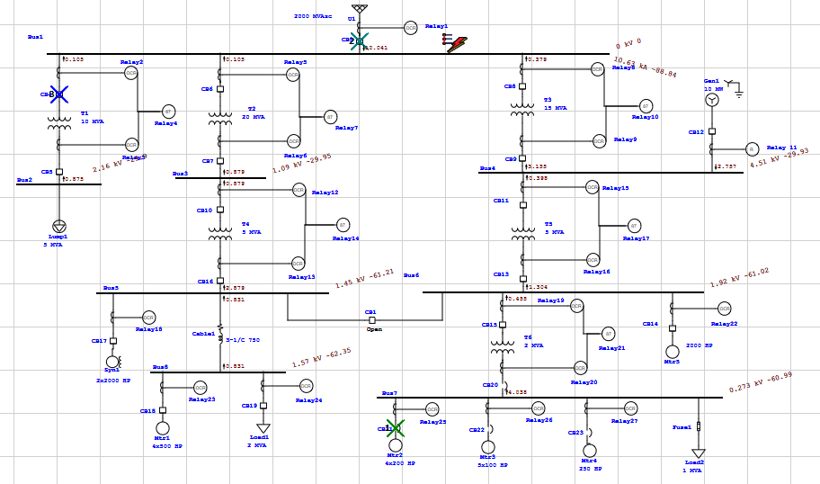

***Fig. 25 Fault at Bus 1(CB-1 Open configuration)***

**Relay Sequence Operation:**

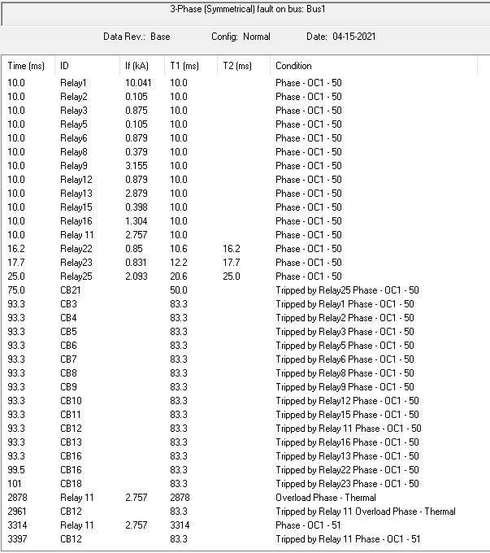

***Fig. 26 Relay Sequence of Operation***

**FAULT AT BUS 2:**

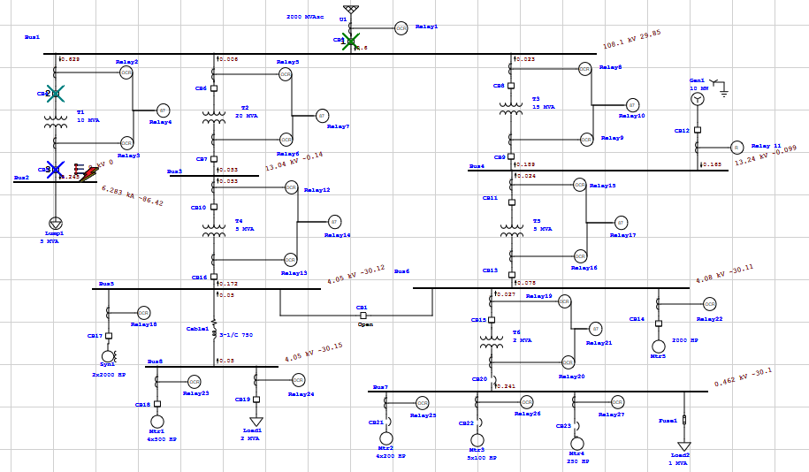

***Fig. 27 Fault at Bus 2(CB-1 Open configuration)***

**Relay Sequence Operation:**

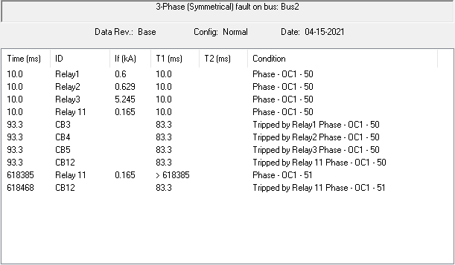

***Fig. 28 Relay Sequence of Operation***

**FAULT AT BUS 3:**

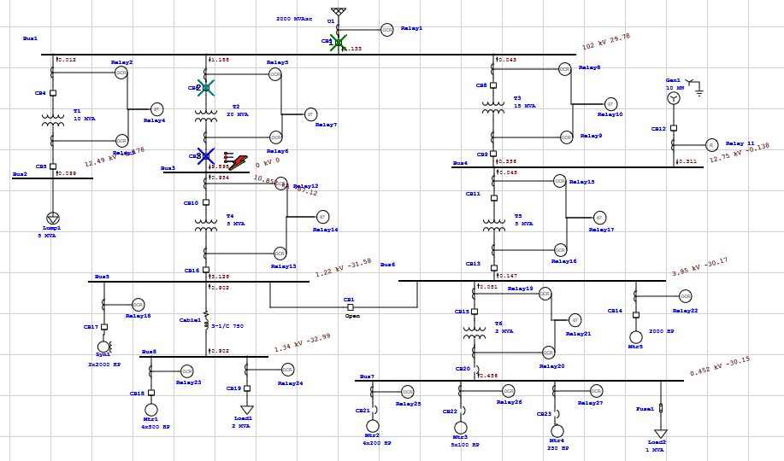

***Fig. 29 Fault at Bus 1(CB-1 Open configuration)***

**Relay Sequence Operation:**

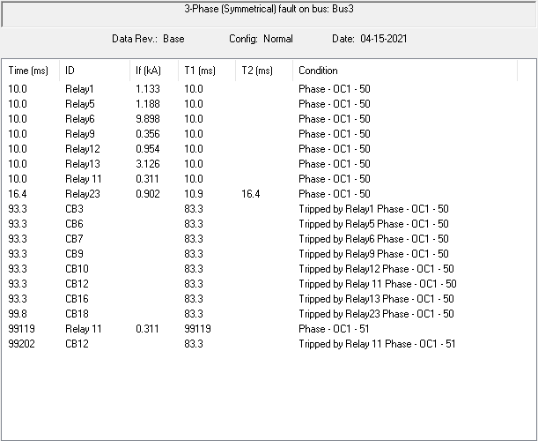

***Fig. 30 Relay Sequence of Operation***

**FAULT AT BUS 4:**

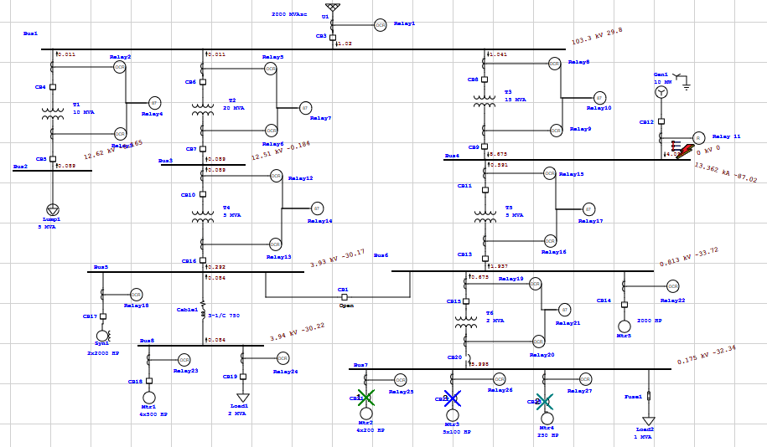

***Fig. 31 Fault at Bus 4(CB-1 Open configuration)***

**Relay Sequence Operation:**

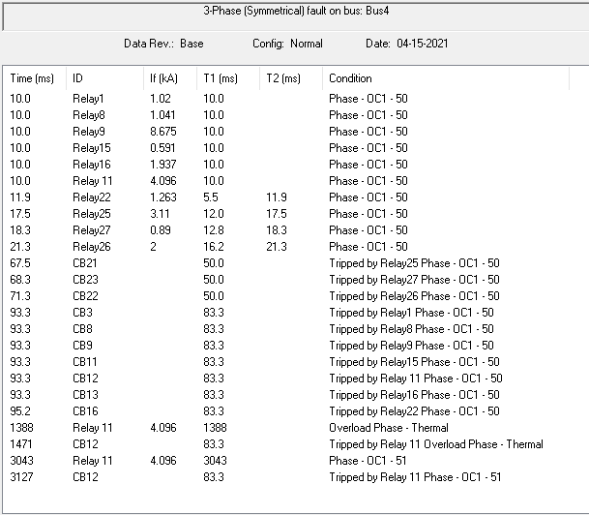

***Fig. 32 Relay Sequence of Operation***

**FAULT AT BUS 5:**

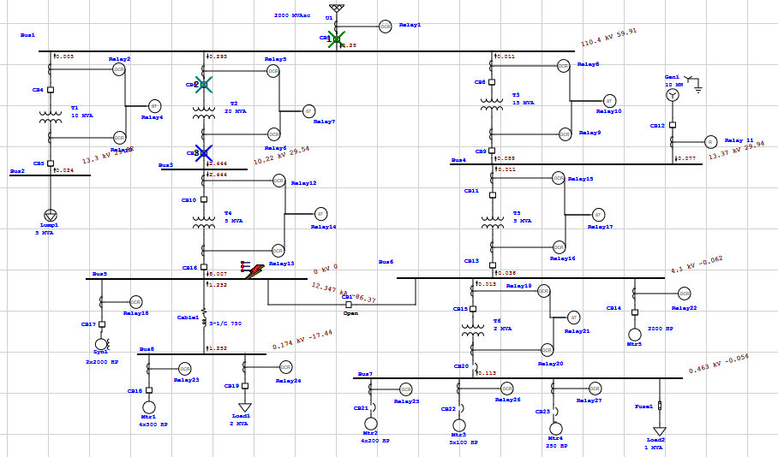

***Fig. 33 Fault at Bus 5(CB-1 Open configuration)***

**Relay Sequence Operation:**

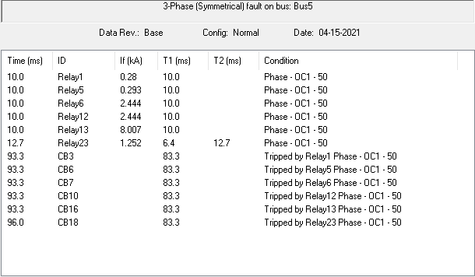

***Fig. 34 Relay Sequence of Operation***

**FAULT AT BUS 6:**

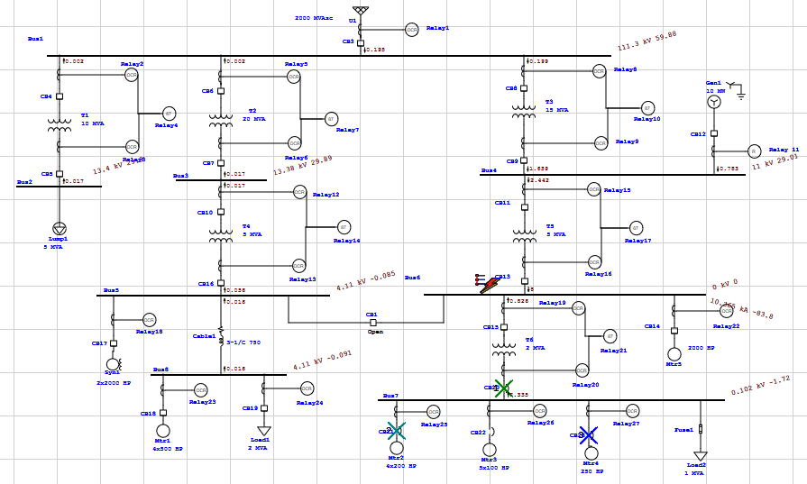

***Fig. 35 Fault at Bus 6(CB-1 Open configuration)***

**Relay Sequence Operation:**

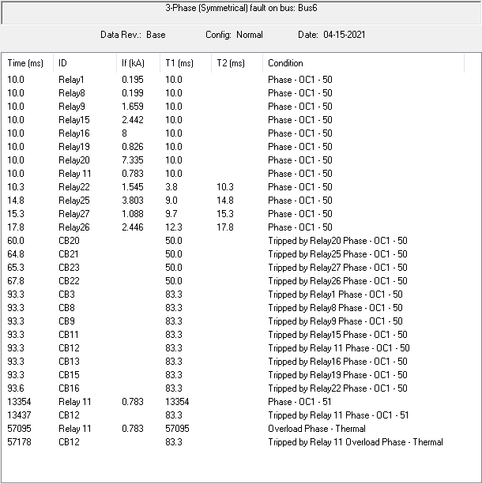



***Fig. 36 Relay Sequence of Operation***

**FAULT AT BUS 7:**

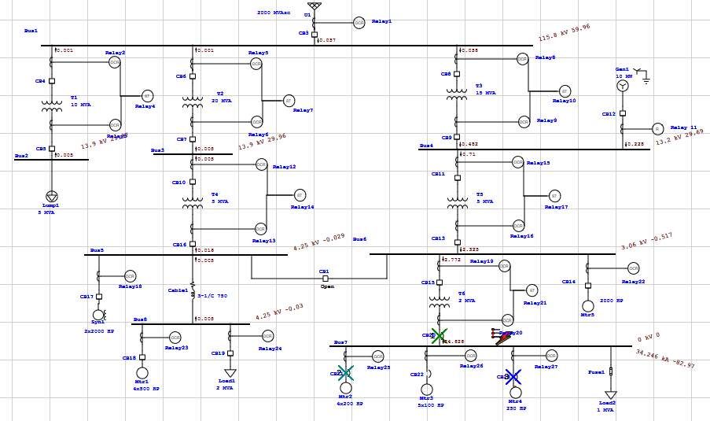

***Fig. 37 Fault at Bus 7(CB-1 Open configuration)***

**Relay Sequence Operation:**

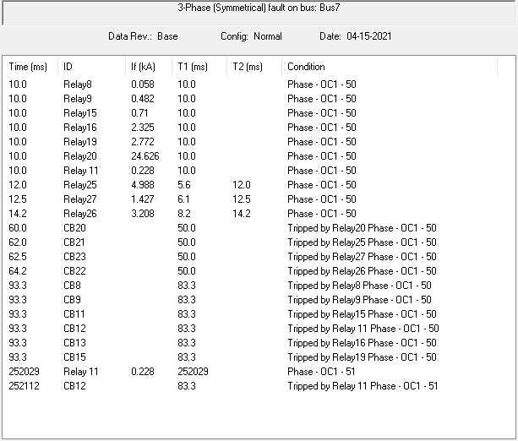

***Fig. 38 Relay Sequence of Operation***

**FAULT AT BUS 8:**

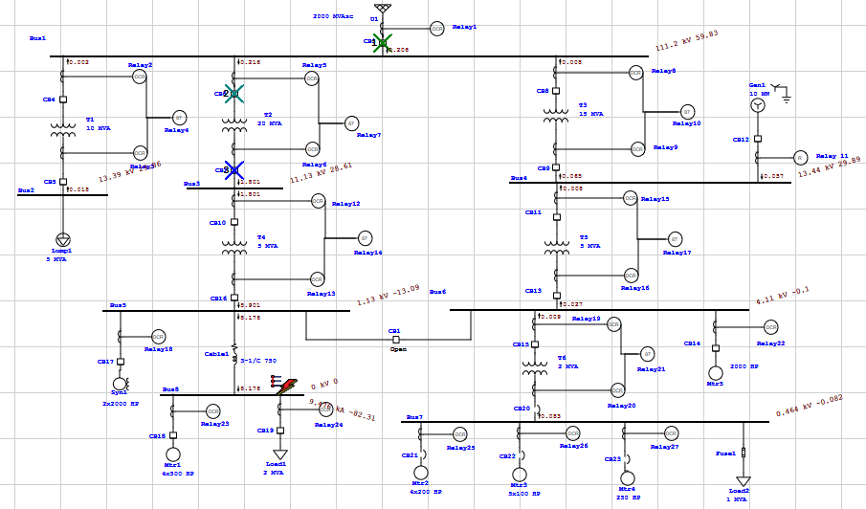

***Fig. 39 Fault at Bus 8(CB-1 Open configuration)***

**Relay Sequence Operation:**

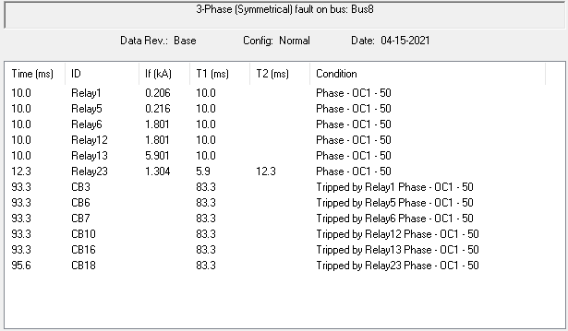

***Fig. 40 Relay Sequence of Operation***

***----------------------------------------------------------------------------------------------------------------------------------***